**STUDENT MANAGEMENT BOT**



By

Sanjiti Pimpalkar

MKSSS Cummins College of Engineering for Women Nagpur



THE DOCUMENTATION IS SUBMITTED IN FULFILLMENT OF THE MENTORSHIP IN PERSISTENT (September – October 2022)

Mentor: Mr. Anil Sharma

**Acknowledgement**

I thank my mentor Mr. Anil Sharma. I would like to thank Kalpana Kudlingar, HR Head, Mr. Sanket Vaidya, Mr. Mahesh Kale at the company for their patience and assistance during my online mentorship. Thanks to their guidance, I was able to develop bot and learn about Git, Python, Oracle. These skills will help me to expand my resume and advance my career.

**1. Introduction**

A computer programme that simulates human conversation through voice commands or chats or both is known as a Chatbot. In shorter terms, the ‘Chatterbot’ is an Artificial Intelligence feature that can be rooted and used through major messaging applications. There are synonyms for this i.e., Talkbot, Bot, IM bot, interactive agent and artificial conversation entity. The Chatbot acts as a virtual assistant that increases to handle simple look-up tasks in both B2C (Business to Consumer) and B2B (Business to Business) environments. A Chatbot is an online software application used to conduct conversations through text or text-tospeech in place of providing direct contact with a live human agent. These are typically used in dialogue systems for multiple purposes including customer services, request routing or for the gathering of information. Early classic Chatbots include ELIZA (1966) and PARRY (1972) based on paranoid schizophrenic behaviour. As you are all well aware, the Chatbot is a conversational AI application built to answer questions. It is powered by NLP (Natural Language processors) and it is trained to field questions from users in various languages. Chatbots are integrated into a variety of digital channels such as websites, mobile apps and workplace dashboards (Addressing business challenges with digital transformation, 2015). Today, Chatbots are accessed through online websites popups and virtual assistants such as Google, Amazon Alexa, messaging apps like Facebook Messenger or WeChat. Chatbots are also classified into usage categories that include: e-commerce, education, entertainment, finance, health, news and productivity (chatbots introduction). In 1950, Alan Turing’s famous study on “Computing Machinery and Intelligence” was published. It proposed the Turing test as a criterion of intelligence. The criterion depends on the ability of a programmed computer to impersonate a human into a real-time written conversation with a human judge to the extent of distinguishing between the programme and a real human being on the reliable basis of conversational consent (Emerc, 2020). The program of ELIZA was published in 1966 by a great scholar named Joseph Weizenbaums, which seemed to be the first Chatbot that was able to fool users into believing that they were conversing with a real human. But later, Joseph himself did not claim that ELIZA was de facto intelligent. Early in 2016, he founded the introduction of the first wave of artificial data technology in the design of Chatbots. For customers, trademark and services, social media platforms like Facebook had developed Chatbots to carry out their daily actions through the messaging platforms. The establishment of Chatbots into a community has bought the time of conversational interface between 9 the end-users. The interface will be entirely conversational and those communications will be indistinguishable from the conversations that persons have with his relatives and friends. Therefore, Chatbots are fondly defined as one of the most advanced and promising tools of expression of interactions between Human and Machines.

**2. Requirement Specifications**

* **Hardware requirements**

1. Processor-13
2. Hard Disk - 5 GB
3. Memory - 1GB RAM

* **Software requirements**

1. Oracle 10g
2. Python
3. Visual Studio Code or Spyder or Pycharm or IDLE

**3. Generalised Structure of Chatbot**

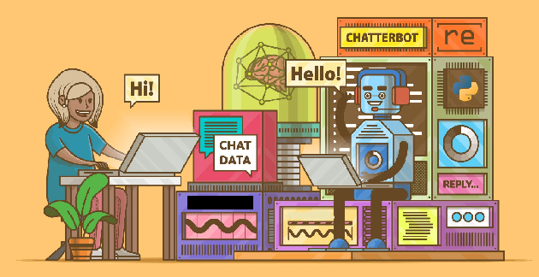

**4. How to use Chatbot?**

1. Run the code.
2. Now the database is connected with the code.
3. Type “Hi” to move further.

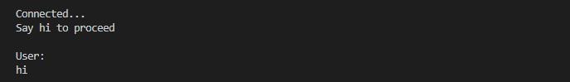

1. Now bot will respond

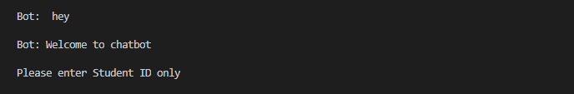

1. Next enter Student Id whose information user want to retrieve.



1. After this bot will display options which user can retrieve information about that Student Id.

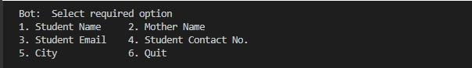

1. Here user have to enter the particular option number which he wants to retrieve data for and will get result.

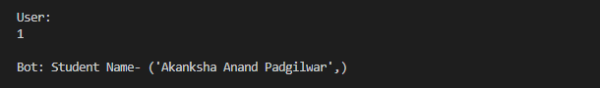

1. Again bot will ask for options.

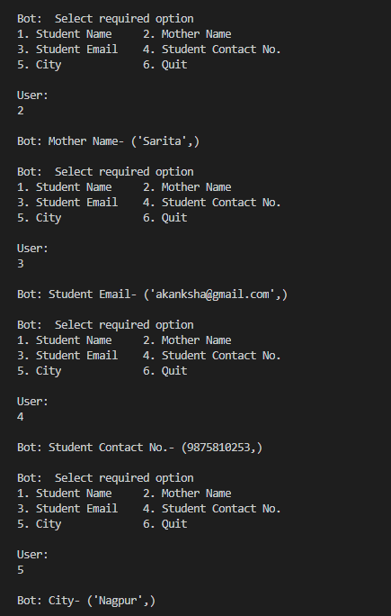

1. If user wants to exit from that Student Id he can go for option 6.

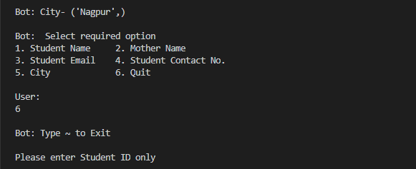

1. User can search for another Student Id by following steps from 5 to 9 or he can quit the chatbot by typing “ ~ ”.

**5. Importance of Chatbot**

The technological point of view represents Chatbots as a natural evolution of a Question-Answering system leveraging Natural Language Processing (NLP). One of the examples of NLP is responding to Questions in traditional languages which have been applied in various enterprises’ end-users. Through ‘user request analysis’ and ‘returning the response’, Chatbots begin to function with these aspects. The major importance of the Chatbot is to interact between the people and services to enhance customer experience. At the same time, they offer companies a new opportunity to reduce the cost of customer services and improve customer’s engagement process (Emerc, 2020). It is important to perform effectively in both of these tasks; human support plays a key role here: the kind of approaches and the platform, configuration of crucial Human Intervention, training and optimising the Chatbot system.

**6. Types of Chatbot**

There are six types of Chatbots mentioned below with their descriptions:

|  |  |
| --- | --- |
| **Types of Chatbots** | **Description** |
| Scripted or Quick reply Bots | This type of Chatbot respond to the customers very quickly through pre-defined knowledge and with specific instructions. |
| NLP Chatbots | NLP is a core of Artificial Intelligence which will be utilised in AI-technology. It maps out user text or voice to intent |
| Service or Action Chatbots | These bots receive customer requests through relevant information from the user and take quick action. This was highly used in the airline industry |
| Social messaging Chatbots | These are integrated with a social messaging platform like Telegram, WhatsApp, Hike, etc. This makes it easy for end-users to interact with the bot directly, just like they do with their relatives and friends. |
| Context enabled Chatbots | These are an advanced type of conversational bots. They utilise ML and AI to remember past conversations with specific users so that they could learn and grow over time. Examples: Alexa, Siri and Google assistant. |
| Voice-enabled Chatbots | This type of Chatbot would create a personalised experience for users. It performs many creative tasks like identifying the voice of user request and answers their queries. |

**7**. **Example of Chatbot that have been used and developed**

‘Bot Artisanz’ is a specialised development of Chatbot Company from Kerala in India. ‘SmatBot’ is also an Indian company working on the development of Chatbots in Hyderabad. It supports generating leads, conducting surveys, scheduling appointments and assists 24/7 for users. With Amazon Alex, the same deep learning technology that is powered by Amazon Alexa, these are now available to any developer and enables you to build quickly and easier with natural languages (companies working on chatbots, 2004). 22

**8. Performance of the Chatbot that are available in the market**

a) Google dialogue flow

b) Microsoft bot framework

c) Amazon Lex

d) Botkit

e) Bot press

f) Bot man

g) Wit.ai

h) Rasa stack

i) SAP Conversational AI

j) IBM Watson

k) Gupshup

l) FlowXO

m) Botsify

n) Pandorabots

o) Chat fuel

p) Many chat

q) Mobile monkey

**9. Growth of Chatbot Market**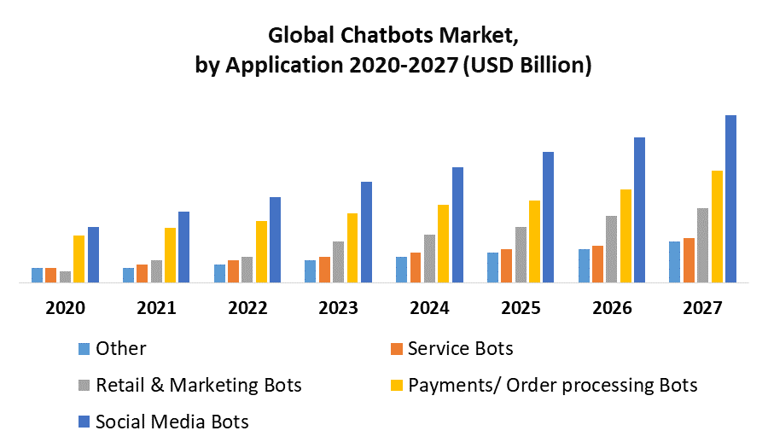

**10. Benefits of Chatbot**

There are many benefits of using Chatbots in customer service compared to traditional options. Being able to offer service to all customers round the clock is one of the biggest benefits that Chatbots offer, while also giving answers immediately. Cancel & Gerhardt (2019) agree with this, stating that when asked from consumers, both of these were the benefits that were mentioned the most when asked how Chatbots can improve the experience of website visitors. Cancel & Gerhardt (2018) were also surprised about the fact that not only millennials understand the benefits of Chatbots, but they also provide benefits for the ageing population. The use of Chatbots allows companies to understand their website visitors even better through data collection. They can track how the visitors interact with the bot to know the most popular questions the visitors have. Saunders (2017) says that when a company has a higher insight into its visitors, it is possible to change the website to offer the information at an earlier stage

**11. Usage of Chatbot and AI in Companies**

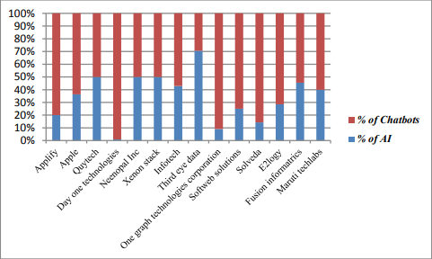

**12. Limitations of the paper**

This paper reflects the limitations only to the application of Chabots. Due to lack of time, it could not take up further steps of research. In the future, the study should take up the cost of installation in India, handling machines, employment in case of technology and growing global developments in the Chatbot arena.

**13. Conclusion and Future Scope**

In this project, we have introduced a chatbot for student information that is able to interact with faculty and student. This chatbot can answer queries in the textual user input. The main objectives of the project were to develop an algorithm that will be used to identify answers related to user submitted questions. To develop a database were all the related data will be stored and to develop a web interface. The web interface developed had one-part simple users. A database was developed, which stores information about questions, answers, keywords, logs and feedback messages. An evaluation took place from data collected after received feedback from the first deployment, extra requirements were introduced and implemented.

**14. Refrences**

oracle.github.io

docs.oracle.com

geeks for geeks

w3schools

javatpoint

maximizemarketresearch.com

research.aimultiple.com

Respondents